Smart Meter Electricity Consumption
Data Pipeline — Internship Progress Report
Medallion Architecture on Databricks (Bronze → Silver → Gold)
By Prashant Mishra
Poornima College of Engineering

1. Project Overview
This project builds an end-to-end batch data pipeline for smart meter electricity consumption data, following the Medallion Architecture (Bronze → Silver → Gold) on Databricks with Delta Lake as the storage format. The goal, per the problem statement, is to ingest raw IoT meter readings, clean and standardize them, detect consumption anomalies, and produce business-ready aggregates for dashboards and billing.
This report gives an honest status of what has actually been built this week — what matches the original problem statement, what was simplified, and what is still pending — so that it is easy to evaluate against the requirements.
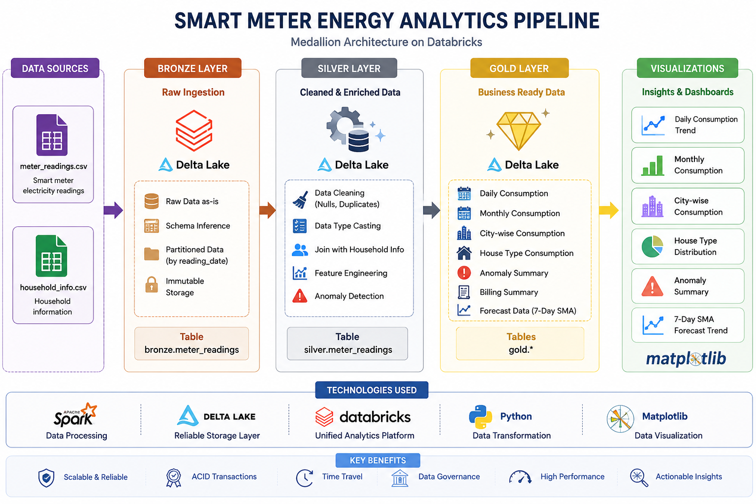
Figure 1: Implemented pipeline architecture — Bronze → Silver → Gold on Databricks with Delta Lake.

2. Data Sources
- meter_readings.csv — hourly readings per meter: meter_id, household_id, timestamp, units_consumed.
- household_info.csv — dimension table: household_id, city, house_type, avg_daily_consumption.
Both files were loaded from a Databricks Unity Catalog Volume using spark.read.csv() with header and schema inference enabled, matching the source structure defined in the problem statement.

3. What Was Actually Built

3.1 Bronze Layer — Raw Ingestion
Implemented in 01_bronze_layer.ipynb:
- Raw CSV read with schema inference into bronze_df.
- Added ingestion_time (current_timestamp) and ingestion_date (current_date) columns for audit tracking.
- Saved as a managed Delta table smart_meter_project_catalog.bronze.meter_readings, partitioned by ingestion_date.
- Write mode used: overwrite (batch load, not incremental).
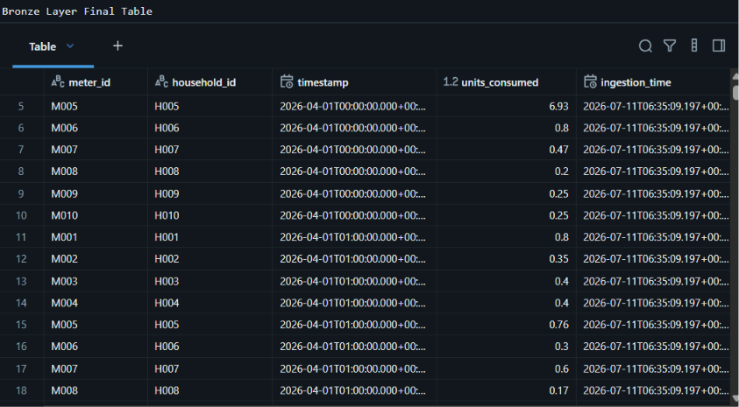
Figure 2: Bronze layer Delta table — raw readings with ingestion_time added.
Gap vs. problem statement: the spec calls for Auto Loader / Kafka-based incremental or streaming ingestion, and partitioning by reading date. What's built here is a one-time batch read partitioned by ingestion_date instead — a reasonable simplification for a first pass, but worth flagging as a known simplification, not a full match to the spec.

3.2 Silver Layer — Cleaning & Anomaly Detection
Implemented in 02_silver_layer.ipynb:
- Null check across all columns (f.count(when(isNull))) — done as a diagnostic step.
- Duplicate check on (meter_id, timestamp) — checked via groupBy + count filter; none found in this dataset, so no dedup logic was actually exercised.
- Missing units_consumed values filled with the overall dataset average (not forward-fill from the previous reading, and no is_imputed flag was created).
- Negative values filtered out using an is_valid flag.
- Joined with household_info on household_id to bring in city and house_type.
- Rolling average computed per meter over the previous 24 readings (Window.partitionBy(meter_id).orderBy(timestamp).rowsBetween(-24,-1)).
- is_spike flagged when units_consumed > 3 × rolling_avg_units.
- possible_outage flagged when a single reading equals 0.
- high_deviation flagged using each meter's overall mean ± 2×stddev across its full history.
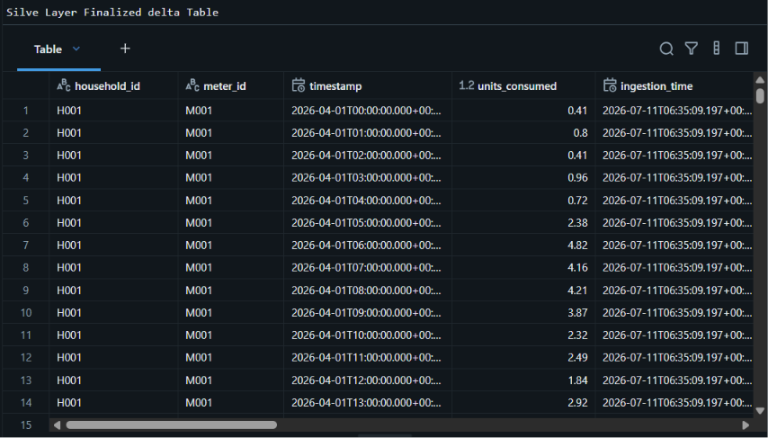
Figure 3: Silver layer Delta table — cleaned readings with anomaly flag columns.
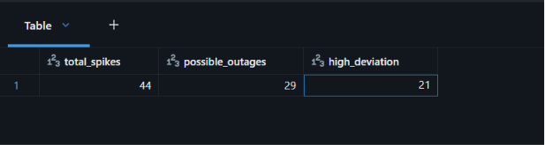
Figure 4: Anomaly counts from the current dataset — 44 spikes, 29 possible outages, 21 high-deviation readings.
Gaps vs. problem statement (genuine, not glossed over):
  - possible_outage currently flags any single zero reading. The spec asks for zero consumption sustained for ≥3 consecutive hours — that consecutive-hour logic isn't implemented yet, so the current flag will over-count short/normal zero readings as outages.
  - high_deviation uses each meter's all-time mean/stddev. The spec asks for deviation from the mean of the same hour-of-week (e.g. comparing a Monday 6pm reading against historical Monday 6pm readings), which is more accurate for catching real behavioral anomalies. This is a meaningfully different (simpler) definition.
  - No timestamp standardization to IST was explicitly done — timestamps were just cast to Spark's timestamp type.
  - No late-arriving data handling (2-hour watermark + Delta MERGE/UPSERT) — writes use mode('overwrite'), so re-runs replace the whole table rather than upserting.

3.3 Gold Layer — Aggregations & Forecast
Implemented in 03_gold_layer.ipynb, all written as Delta tables under the gold schema:
- gold.daily_consumption — total/avg units, household & meter counts per day.
- gold.monthly_consumption — same aggregates per month.
- gold.city_consumption — consumption grouped by city.
- gold.house_type_consumption — consumption grouped by house type.
- gold.anomaly_summary — single-row rollup of total spikes / outages / high-deviation counts.
- gold.forecast_data — per-meter 7-day simple moving average of daily consumption, using a rowsBetween(-6, 0) window on reading_date (correctly matches the spec's 7-day SMA definition).
- Peak hour per day — added in 03_gold_layer.ipynb. Hour is extracted from the timestamp, units are summed per (reading_date, reading_hour), and row_number() over a window partitioned by reading_date and ordered by hourly_units descending picks the top hour for each day. This is computed from real data, not hardcoded.
- gold.billing_summary was created (per household per month) but then dropped at the end of the notebook — it does not exist in the current catalog. Worth deciding intentionally whether to keep or fully remove it.
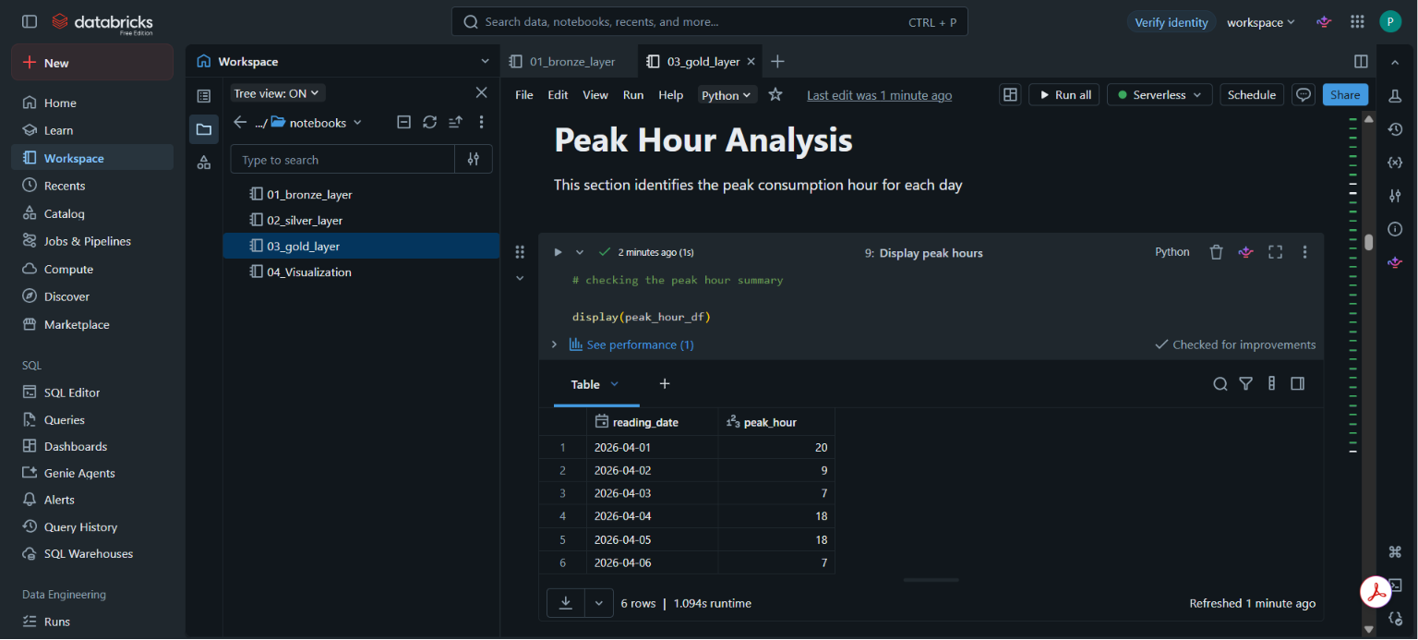
Figure 8b: Peak consumption hour per day, computed via window function, not hardcoded.
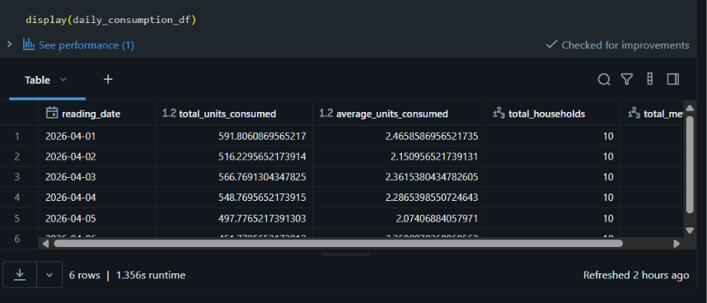
Figure 5: gold.daily_consumption.
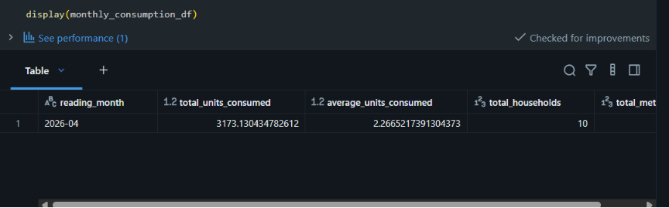
Figure 6: gold.monthly_consumption.
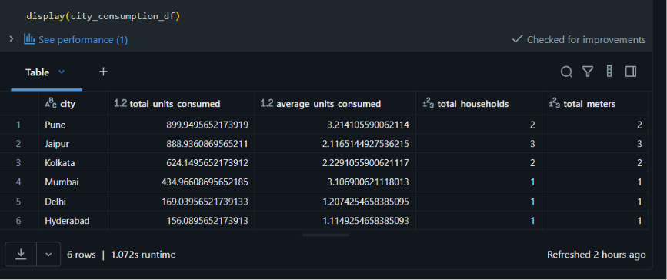
Figure 7: gold.city_consumption — Pune and Jaipur show the highest total consumption.
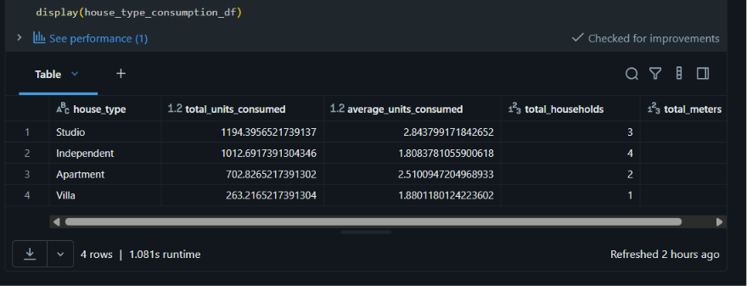
Figure 8: gold.house_type_consumption — Studio apartments show the highest total consumption.
Gap vs. problem statement: the spec's gold.consumption_trends table combines daily totals, peak_hour, sma_7day, and anomaly_count into one row-per-meter-per-day table. peak_hour is now correctly computed (see above), but daily, monthly, city, house_type, forecast, and peak_hour still live as separate tables rather than one joined consumption_trends table, and there's still no row-level gold.anomaly_alerts table (with expected_value, deviation_pct, severity) — only the single aggregate anomaly_summary exists.

3.4 Visualization
Implemented in 04_Visualization.ipynb using matplotlib, reading directly from the Gold Delta tables:
- Daily consumption trend (line chart)
- Monthly consumption (bar chart)
- City-wise consumption (bar chart)
- House-type consumption (pie chart)
- Anomaly summary (bar chart)
- Daily units vs. 7-day SMA (line chart, first 100 rows)
All six charts are present and functional. Note: the SMA chart currently just takes .head(100) after sorting by date across all meters combined, rather than isolating one meter's series — worth checking whether that plot is actually meaningful for a mixed multi-meter dataset, or if it should be filtered per meter_id.

3.5 Catalog Organization
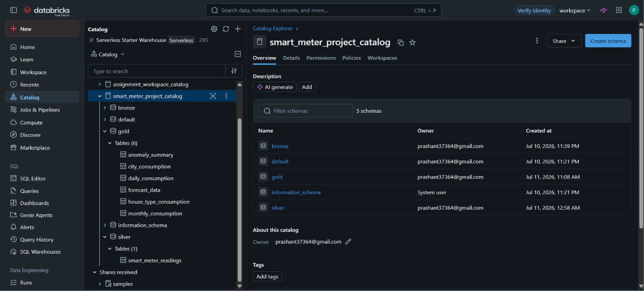
Figure 9: Unity Catalog — smart_meter_project_catalog with bronze / silver / gold schemas and their tables.
The catalog is cleanly organized with separate schemas per layer, which reflects the medallion structure correctly and is easy for a reviewer to navigate.

4. Honest Status Summary
This is a straightforward view of what's fully done, what's partially done, and what's not done yet, measured against the original problem statement — not against a lowered bar.
Component | Status | Notes
Bronze ingestion | Partial | Batch CSV load works and saves to Delta correctly; streaming/Auto Loader ingestion from the spec is not implemented.
Null / duplicate checks | Done | Checked for both; average-fill used for missing values instead of forward-fill.
Spike detection | Done | 3× rolling average over last 24 readings — logic matches the spirit of the spec.
Outage detection | Partial | Flags any single zero reading; consecutive ≥3-hour rule not implemented.
Deviation detection | Partial | Uses overall meter mean ± 2σ, not hour-of-week mean ± 2σ as specified.
Late-arriving data / MERGE | Not started | All writes use overwrite mode; no watermarking or upsert logic.
Daily/Monthly/City/House aggregates | Done | All four Gold tables built and verified.
Peak hour per day | Done | Computed via row_number() window function over real hourly sums, not hardcoded.
7-day SMA forecast table | Done | Correctly implemented with rowsBetween(-6,0).
Anomaly alert table (row-level) | Not started | Only an aggregate count table exists, not the row-level gold.anomaly_alerts table from the spec.
Billing summary | Not started | Table was built then dropped in the same notebook — currently absent from the catalog.
Visualization | Done | 6 charts covering all key Gold tables.

5. Suggested Questions / Discussion Points for the Mentor
Genuine, work-based questions that come directly from the gaps above — good to raise in the session:
- For the outage flag, is a single zero reading acceptable for this stage, or should I implement the consecutive ≥3-hour check before moving on?
- Is comparing against hour-of-week mean/stddev (instead of the meter's overall mean) important enough to redo now, or can it wait for a later iteration?
- Since I'm using mode('overwrite') everywhere, is that acceptable for a project of this scale, or should I switch to MERGE/upsert to reflect the late-arriving data requirement in the spec?
- Should I keep the billing_summary table or was dropping it intentional — do we still need it for the final deliverable?
- Now that peak_hour, daily totals, SMA, and anomaly counts each live in separate Gold tables, should I join them into one consumption_trends table like the spec describes, or is keeping them separate fine for querying?

6. Conclusion
The medallion architecture is correctly set up end-to-end — data flows from raw CSVs through Bronze, into a cleaned and enriched Silver layer, into multiple business-ready Gold tables, and finally into working visualizations. The core mechanics (Delta tables, window functions, joins, aggregations, 7-day SMA) are implemented correctly and match Delta Lake best practices. The main gaps are around the more advanced parts of the anomaly detection spec (consecutive-hour outages, hour-of-week deviation) and the incremental/streaming/late-data handling requirements, which weren't attempted yet this week. These are reasonable next steps rather than mistakes — flagging them clearly here so the evaluation is accurate.

